**CLOUD COMPUTING LAB**



**SUBMITTED TO**SIR WAQAS SALEEM  
  
**SUBMITTED BY**  
HAMNA MAHMOOD

2023-BSE-025  
BSE V-A

**Lab 04**

**Virtualization & Linux Fundamentals**

**Task 1 – Verify VM resources in VMware**

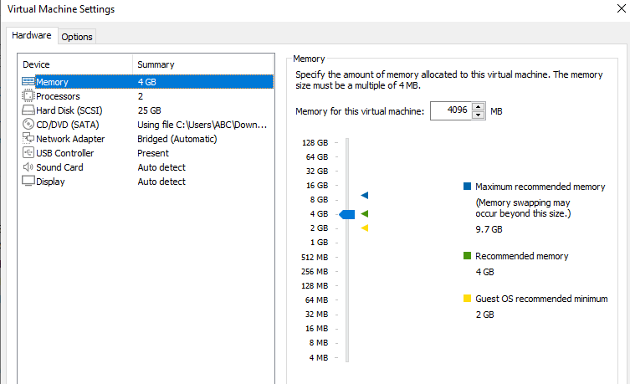

**Task 2 – Start VM and log in (use your preferred host terminal method only)**

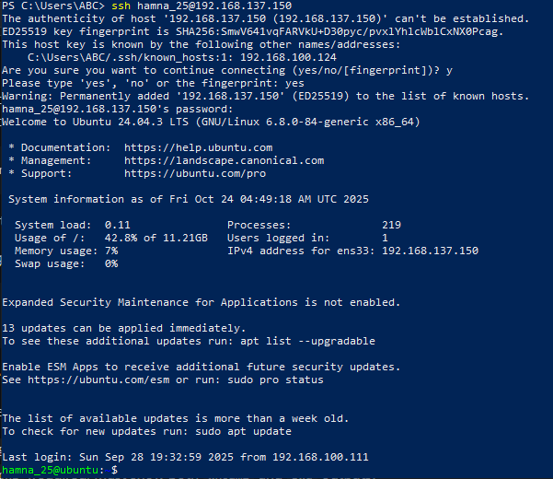



**Task 3- Filesystem exploration — root tree and dotfiles**

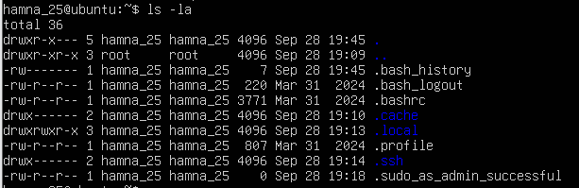





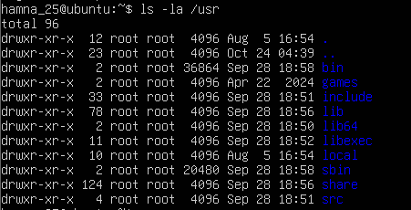

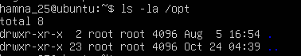

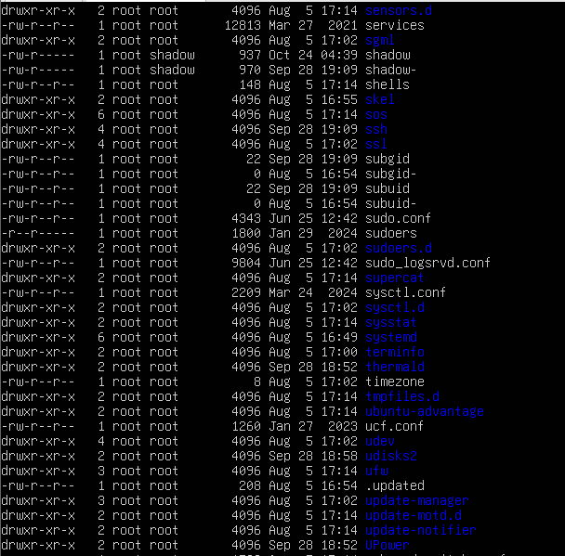

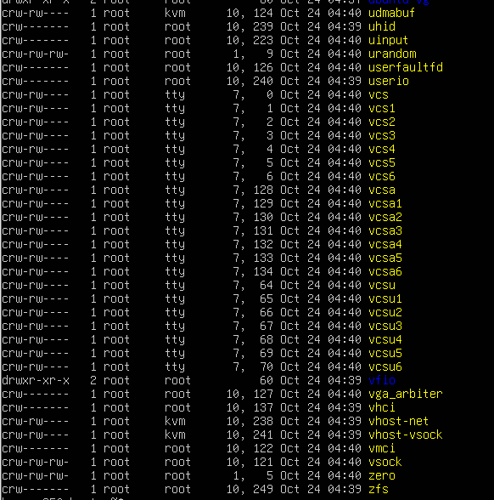

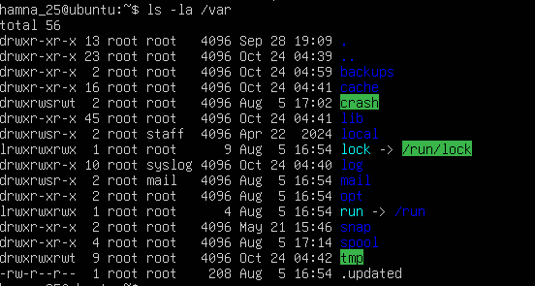

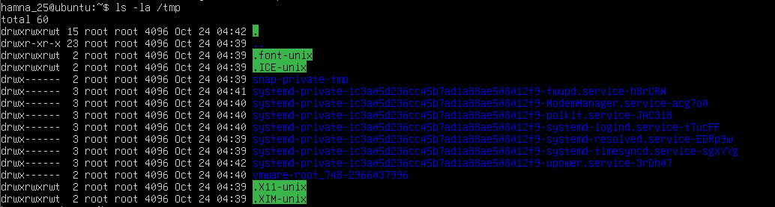

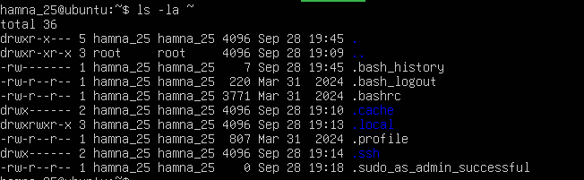

**Task 4 – Essential CLI tasks — navigation and file operations**













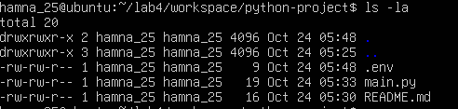











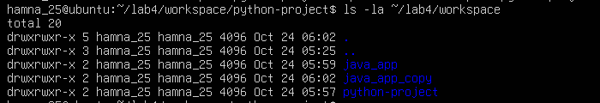

**Task 5 – System info, resources & processes**



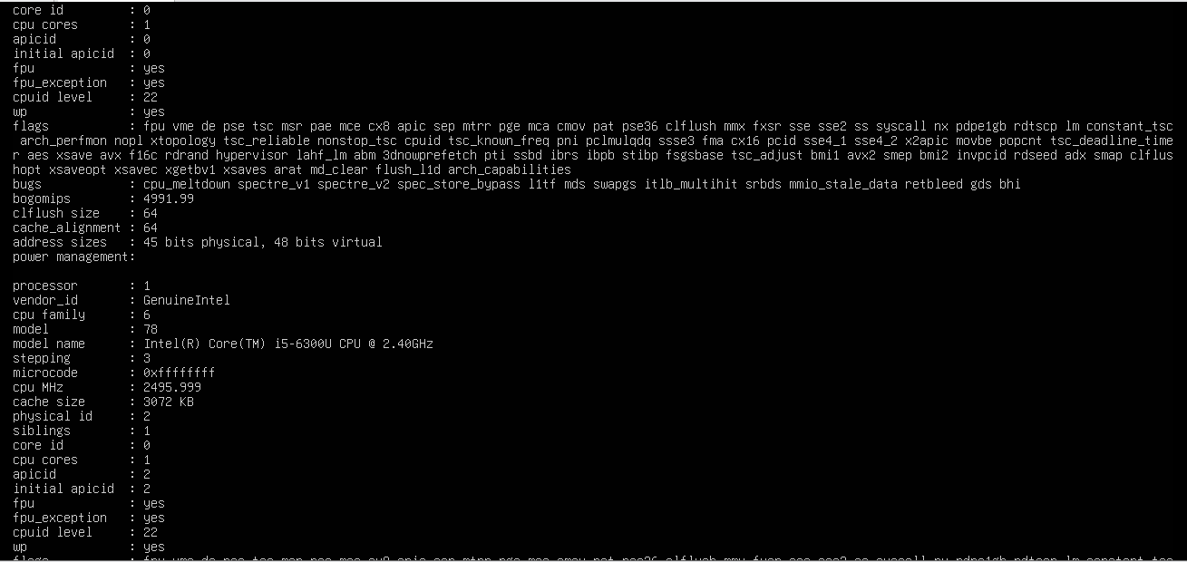

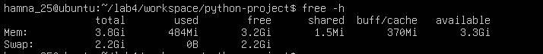

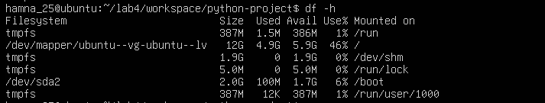

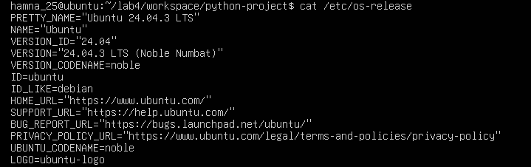

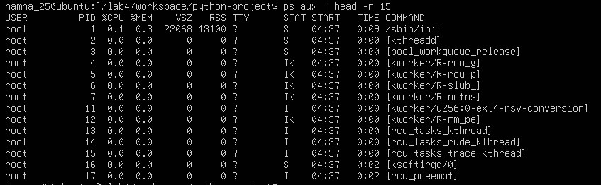

**Task 6 – Users and account verification (no sudo group change)**

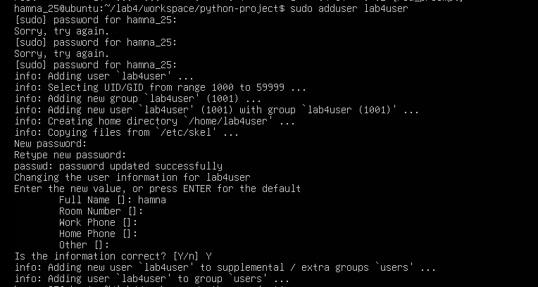





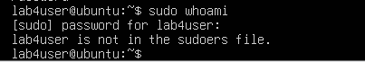



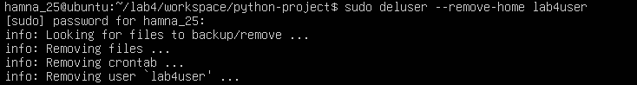

**Bonus Task 7 – Create a small demo script using an editor and run it**

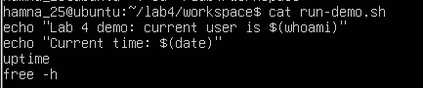



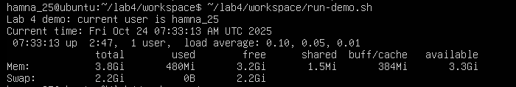

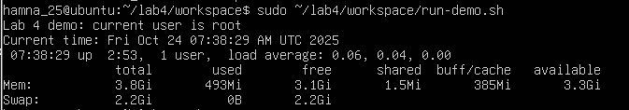

**Exam Evaluation Questions**

1. **Connect to the Ubuntu VM remotely from your host terminal**

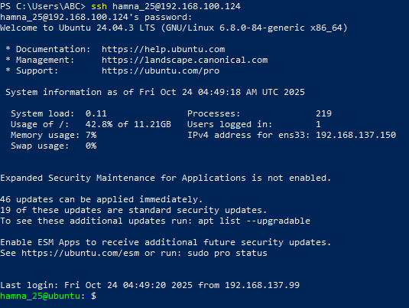

**Verify your current user and home directory path.**

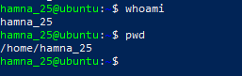

**Confirm you are connected to the correct host machine.**

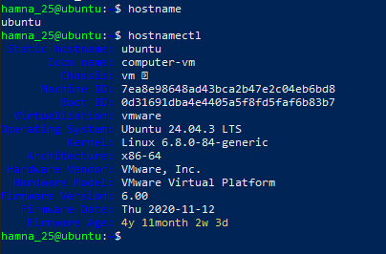

1. **Filesystem Inspection for Forensic Evidence**

**Display the contents of the root directory**



**Display the OS version and release information.**

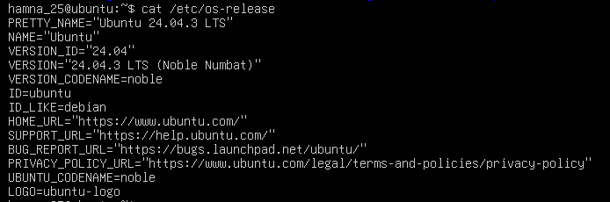

**Explore and record directory listings for /bin, /sbin, /usr, /opt, /etc, /dev, /var, and /tmp.**

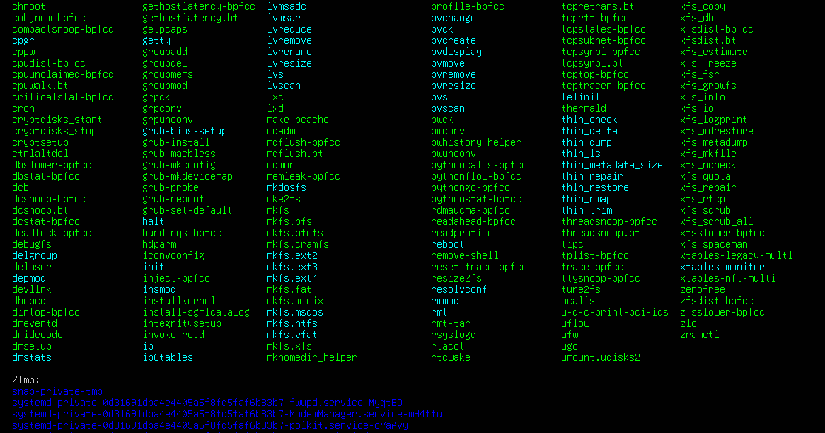

**Display all hidden files in your home directory.**



**Create a markdown file summarizing your findings on key binary directories.**

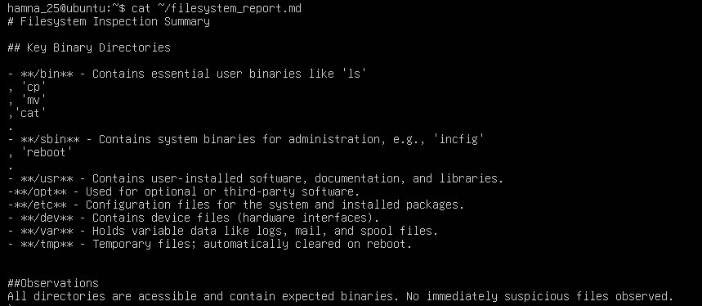

1. **Evidence handling & File Operations**

**Create a structured folder hierarchy under your home directory for analysis.**

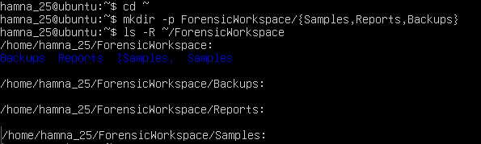

**Create three text files, including one hidden file, in your workspace.**

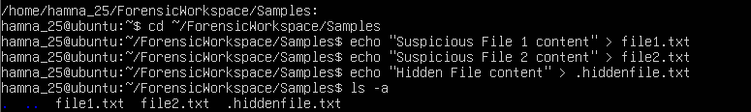

**Create a backup copy of one file, rename it, and then delete it after verification.**

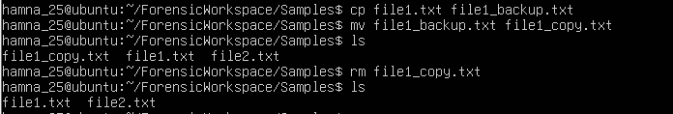

**Copy the entire workspace as an evidence backup folder.**



**Display your command history to document all actions performed.**

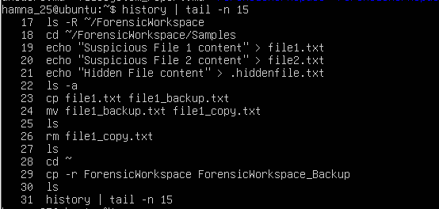

**Demonstrate Linux auto-completion by typing a partial command or filename.**



1. **System Profiling and Process Monitoring**

**Display the system’s OS and kernel version for the investigation report.**

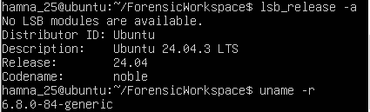

**Display CPU, memory, and disk usage information.**



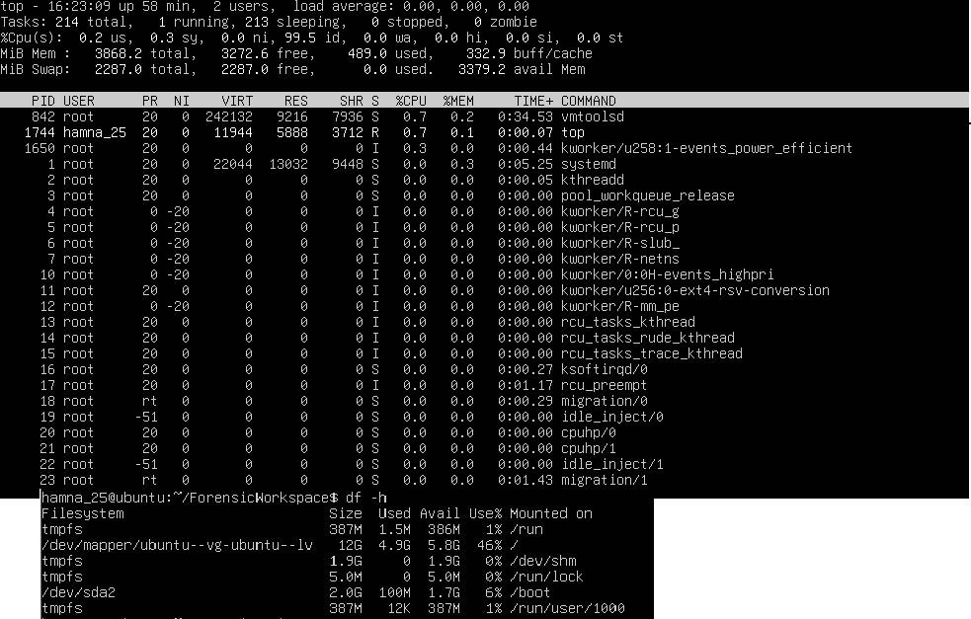

**Display all active running processes to identify suspicious activity.**

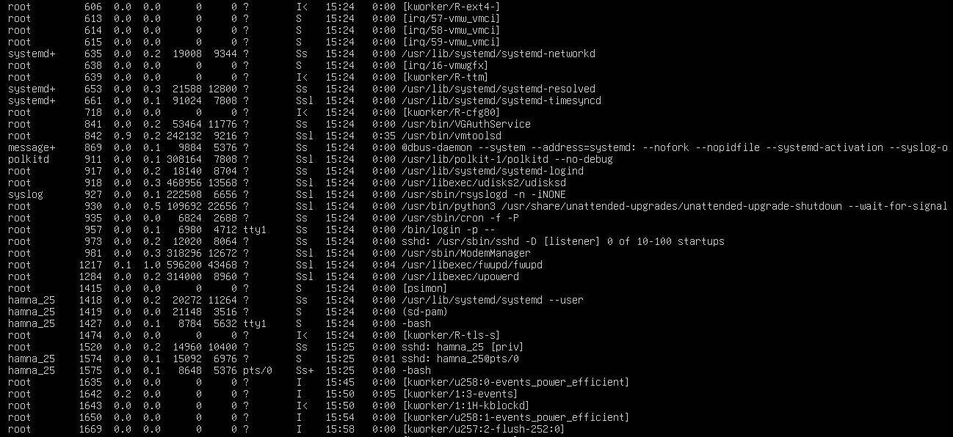

1. **User Account Audit & Privilege Escalation Simulation**

**Create a new test user named lab4user.**

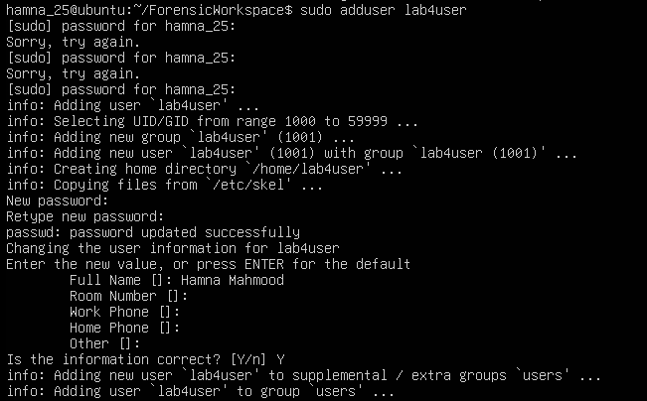

**Verify that the new user record exists in the system’s user database.**



**Log in as lab4user and confirm successful login.**

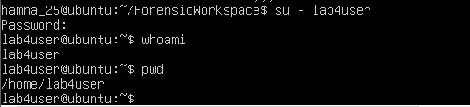

**Attempt to run an administrative command as lab4user (expect permission denied).**

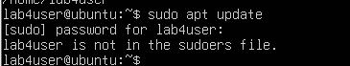

**Switch back to your main analyst account.**



**Inspect the system authentication logs located at /var/log/auth.log to determine whether the lab4user account attempted any logins (successful or failed).**

